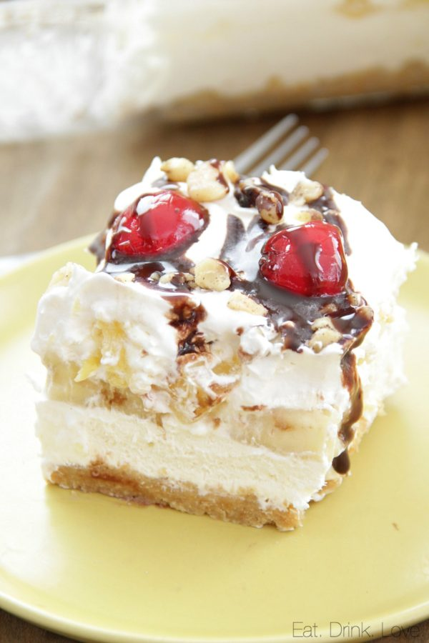**Ingredients:**

* 2 cups graham cracker crumbs
* 1/2 cup unsalted butter, melted (1 stick)
* 1 (8-ounce) block plain cream cheese
* 16 ounces Cool Whip, thawed, divided (or 4 cups heavy whipping cream)
* 1/2 cup powdered sugar
* 1 teaspoon vanilla extract
* 1 (20-ounce) can crushed pineapple, drained
* 4 bananas, sliced

**Directions:**

Spray a 9x13 baking dish with non-stick spray. In a bowl, stir together the graham cracker crumbs and melted butter. Pour the mixture into the baking dish and spread into an even layer, pressing down to set into place. Place the dish in the fridge.

If you are using Cool Whip: Add 8 ounces of the Cool Whip and cream cheese to a mixing bowl and beat until fluffy and combined. Beat in the vanilla and powdered sugar. Note: If you are making homemade whipped cream: Pour the whipping cream to a bowl and beat until soft peaks form, about 5 minutes. Spoon out about 2 cups of the whipped cream and set aside. Add the cream cheese, vanilla, and powdered sugar with the remaining whipped cream and mix until just combined.

Take the baking dish out of the fridge. Spread the Cool Whip/whipped cream mixture on top of the graham cracker crust evenly. Arrange banana slices in a single layer on top, pressing down gently. Then spread the crushed pineapple on top of the banana slices.

Spoon the remaining Cool Whip or whipped cream on top and spread with a knife to cover the bananas and pineapple. Cover with foil and chill for at least 4 hours. Before serving, garnish with chopped walnuts, maraschino cherries, chocolate syrup, or sprinkles. Slice and serve. The dessert is best eaten within 2-3 days.