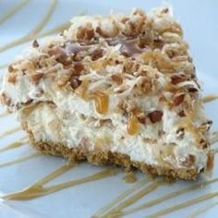

Millionaire Pie
(makes 2 pies)

- large can crushed pineapple, drained
- can condensed milk
6 tbsp. Lemon juice
1 large Cool Whip
- cup pecans, ground ior chopped
- baked pie shells (or 2 graham cracker or vanilla wafer crusts)

Mix all ingredients and put in pie shell. Refrigerate

