Being Prepared
With the approach of Hurricane season, and as we turn our thoughts to storm preparations, remember that in the event of an evacuation, a good option is to cut off the water service at the customer isolation valve located on the customer side of the meter. This will help stop water loss and stabilize water pressure. This procedure can apply to vacations or extended time away from your residence as well.

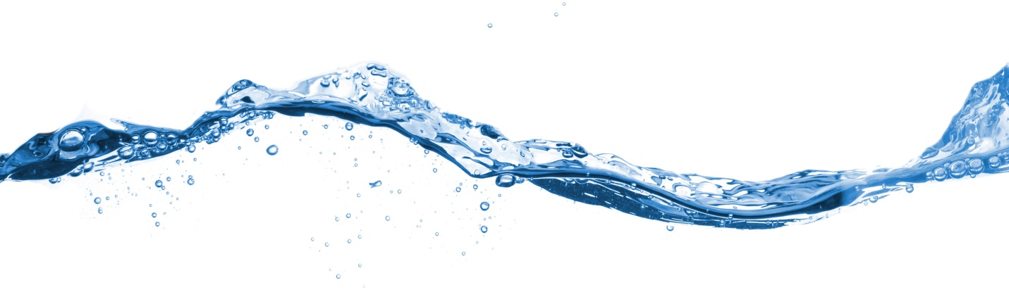

Using Water Wisely
Even though we have a solid supply of Groundwater, we recognize the importance of protecting this valuable life sustaining source. We would like to encourage everyone to use good conservation management actions by using Water wisely, and by helping the NHWSC by reporting leaks, broken lines or leaky valves. This will enable us to continue to serve our customers with good quality water.

